Session – (A / B / C / D)

TITLE OF PAPER

Authors’ Names

Authors’ Affiliations with complete address including country
Authors’ Email Address

ABSTRACT

An abstract is a single paragraph, without indentation, compendious summary of a paper's substance including research question, background, purpose, methodology, results, and conclusion in 300 to 500 words. This one-page abstract should be prepared in the following format: (1) Use a sheet of A4 size paper. (2) Use 12 points Times New Roman for the main text and smaller fonts may be used for figure captions. (3) The width of each line should not exceed 17.5 cm or 7.0 inch. (4) The session, i.e., theme, to which this paper is preferably sent should be identified on the first row of this abstract with underline. (5) Session, title, author's names, and affiliations should be centered. (6) Insert two blank lines between the email addresses and the main text. (7) Start the first line of the main text by leaving no space. (8) Main text should be fully justified with a single spacing. (9) Use bold face with bigger fonts for title but not for authors, affiliations, and the main text. (10) Please underline the presenting author if possible. (11) Leave the space of 2.5 cm or 1.0 inch at lease on the bottom of the text. Page number will be printed there. (12) Up to 6 keywords are mandatory. (13) Figures and References are optional. (14) Deadline for online submission is 20 April 2020.

Keywords: Single, Paragraph, Summarizes, words indentation (maximum 6 words)

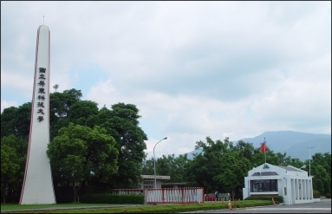 |  | 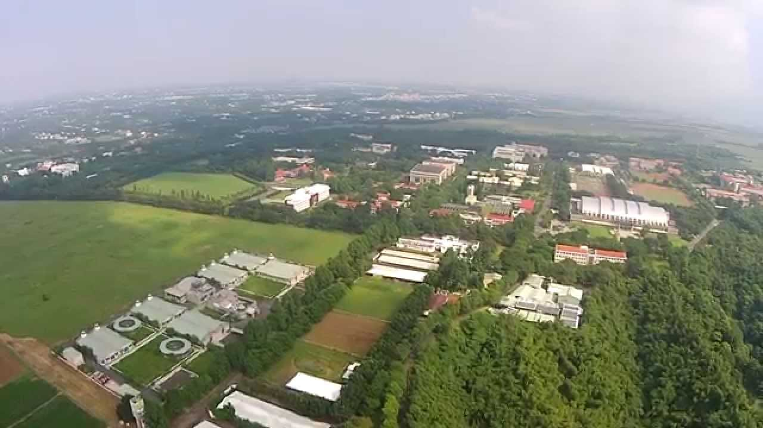
Fig. 1. Main entrance to the university (NPUS) | Fig. 2. A scenery in the university main campus | Fig. 3. A bird-eye view of the university main campus in Neipu county

References
[1] C.R. Clemmer, T.P. Beebe Jr., Science 251 (1991) 640
[2] J. Chen, K. Sattler, N. Murthy, Phys. Rev. 67 (2013) 158

